13.41: 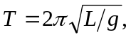 so for a different acceleration due to gravity 